**nOTE D’HONORAIRES**

**CHIRURGIE OCULAIRE EXTRA-MURALE**

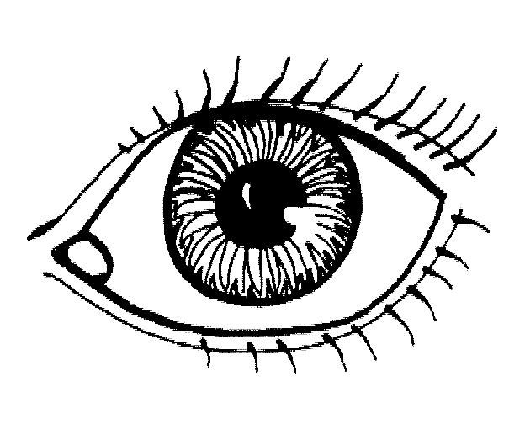

|  |  |  |  |  |  |  |  |  |  |  |  |  |  |
| --- | --- | --- | --- | --- | --- | --- | --- | --- | --- | --- | --- | --- | --- |
| Centre chirurgical de l’œil : |  | | | | | | | | | | | | |
|  | | | | | | | | | | | | | |
| N° de la note d’honoraires : | |  | Date : |  |  | / |  |  | / | 2 |  |  |  |

|  |  |  |  |  |  |  |  |  |  |  |  |  |  |  |  |  |  |  |  |  |  |  |  |  |  |  |  |  |  |  |  |  |  |  |  |  |  |  |  |  |  |  |  |  |  |  |  |  |  |  |  |  |  |  |  |
| --- | --- | --- | --- | --- | --- | --- | --- | --- | --- | --- | --- | --- | --- | --- | --- | --- | --- | --- | --- | --- | --- | --- | --- | --- | --- | --- | --- | --- | --- | --- | --- | --- | --- | --- | --- | --- | --- | --- | --- | --- | --- | --- | --- | --- | --- | --- | --- | --- | --- | --- | --- | --- | --- | --- | --- |
| **Patient** | | | | | | | | | | | | | | | | | | | | | | | | | | | | | | | | | | | | | | | | | | | | | | | | | | | | | | | |
|  | | | | | | | | | | | | | | | | | | | | | | | | | | | | | | | | | | | | | | | | | | | | | | | | | | | | | | | |
| N° Medi-Card® et/ou n° de police | | | | | | | | | |  | |  | |  | |  | |  | |  | |  | |  | |  | |  |  |  | |  | |  | |  | |  | |  | |  | |  | |  | |  | |  | |  | |  | |
|  | | | | | |  | | | | | | | | | | | | | | | | | | | | | | | | | | | | | | | | | | | | | | | | | | | | | | | | | |
| Nom |  |  |  |  |  | |  |  |  | |  | |  | |  | |  | |  | |  | |  | |  | | Prénom | | | |  | |  | |  | |  | |  | |  | |  | |  | |  | |  | |  | |  | |  |

|  |  |  |  |  |  |  |  |  |  |  |
| --- | --- | --- | --- | --- | --- | --- | --- | --- | --- | --- |
| Date de naissance |  |  | / |  |  | / |  |  |  |  |

|  |  |  |  |  |  |  |  |  |  |  |  |  |  |  |  |  |  |  |  |  |  |  |  |  |  |  |  |  |  |  |  |  |
| --- | --- | --- | --- | --- | --- | --- | --- | --- | --- | --- | --- | --- | --- | --- | --- | --- | --- | --- | --- | --- | --- | --- | --- | --- | --- | --- | --- | --- | --- | --- | --- | --- |
| Rue |  |  |  |  |  |  |  |  |  |  |  |  |  |  |  |  |  |  |  |  |  |  |  |  |  |  |  |  |  |  |  |  |

|  |  |  |  |  |  |  |  |  |  |  |  |  |  |  |  |  |  |  |  |  |  |  |  |  |  |  |
| --- | --- | --- | --- | --- | --- | --- | --- | --- | --- | --- | --- | --- | --- | --- | --- | --- | --- | --- | --- | --- | --- | --- | --- | --- | --- | --- |
| N° |  |  |  |  | Bte |  |  |  | Code postal |  |  |  |  | Localité |  |  |  |  |  |  |  |  |  |  |  |  |

|  |  |  |
| --- | --- | --- |
| **Type d’intervention :** |  | 🞏 **œil gauche** 🞏 **œil droit** |

|  |  |  |  |  |  |  |  |  |  |  |
| --- | --- | --- | --- | --- | --- | --- | --- | --- | --- | --- |
| **Date de l’intervention :** |  |  | / |  |  | / | 2 |  |  |  |

**Honoraires - Matériel médical - Implants**

|  |  |  |
| --- | --- | --- |
| Description des prestations  (y compris N° de notification (1)) | Codes de nomenclature(1) | Honoraires (2) |

|  |  |  |
| --- | --- | --- |
|  |  |  |
|  |  |  |
|  |  |  |
|  |  |  |
|  |  |  |
|  |  |  |
|  |  |  |
|  |  |  |
|  |  |  |
|  |  |  |
|  |  |  |
|  |  |  |
|  |  |  |
|  |  |  |

|  |  |  |
| --- | --- | --- |
|  | **Total général** | € |

|  |  |  |
| --- | --- | --- |
| La participation forfaitaire de | **€** | (par œil) à la charge de DKV est à verser : |

|  |  |  |  |  |  |  |  |  |  |  |  |  |  |  |  |  |  |  |  |
| --- | --- | --- | --- | --- | --- | --- | --- | --- | --- | --- | --- | --- | --- | --- | --- | --- | --- | --- | --- |
| au n° compte IBAN : | B | E |  |  | - |  |  |  |  | - |  |  |  |  | - |  |  |  |  |

|  |  |  |  |  |  |  |  |  |  |  |  |  |  |  |  |  |  |  |  |  |  |  |  |  |  |  |  |  |  |
| --- | --- | --- | --- | --- | --- | --- | --- | --- | --- | --- | --- | --- | --- | --- | --- | --- | --- | --- | --- | --- | --- | --- | --- | --- | --- | --- | --- | --- | --- |
| au nom de : |  |  |  |  |  |  |  |  |  |  |  |  |  |  |  |  |  |  |  |  |  |  |  |  |  |  |  |  |  |

|  |  |
| --- | --- |
| Communication : |  |

66614_FR_4_201401

Le dispensateur (n° d’identification INAMI, nom et signature) :

(1) Si d’application

(2) Prix avant déduction des interventions de la mutualité et de DKV : voir respectivement l’attestation de soins donnés (à transmettre à la mutualité de l’ayant droit) + forfait ‘tout-inclus’ par œil (à payer par DKV)

1/2

|  |  |  |
| --- | --- | --- |
| **CHIRURGIE OCULAIRE EXTRA-MURALE** | | |
| **TRAITEMENTS CHIRURGICAUX** | **NOMENCLATURE INAMI** | **INTERVENTION FORFAITAIRE DKV**  **(‘TOUT-INCLUS’ PAR OEIL)** |
|  |  |  |
| Opération de la cataracte | 246912 - 246923 | € 831 |
| Cataracte - implantation secondaire | 246610 - 246621 | € 512 |
| Greffe de cornée | 246212 - 246223 | € 731 |
| Intervention combinée de greffe cornéenne et opération de la cataracte | 246890 - 246901 | € 1.189  66614_FR_4_201401 |
| Vitrectomie | 246654 - 246665 | € 1.097 |
| Réparation décollement de la rétine | 246772 - 246783 | € 1.097 |
| Injection intravitréenne | 248334 - 248345 | € 123 |
| Strabisme primaire | 247590 - 247601 | € 585 |
| Strabisme réintervention | 247656 - 247660 | € 1.097 |
| Enucléation | 247052 - 247063 | € 438 |
| Trabéculectomie (glaucome) | 246573 - 246584 | € 548 |
| Iridectomie | 246551 - 246562 | € 438 |

|  |  |  |
| --- | --- | --- |
| Entropion ou ectropion * | 245851 - 245862 | € 293 |
| Blépharoplastie médicale * | 245733 - 245744 | € 293 |
| Ptose * | 245814 - 245825 | € 476 |
| Ptérygion * | 246094 - 246105 | € 152 |

**\* accord écrit préalable de DKV nécessaire**

En application des conventions conclues en janvier 2010 et en décembre 2012 entre l’Union Professionnelle de la Chirurgie Extramurale (union soutenue par le Syndicat Ophtalmologique ‘SOOS’, l’Union Professionnelle Belge des Médecins Spécialistes en Ophtalmologie et Chirurgie Oculaire ‘UPBMO’ et la Belgian Society of Cataract and Refractive Surgery ‘BSCRS’) et DKV Belgium S.A.

2/2