**HONORARIUMNOTA**

**EXTRA-MURALE OOGHEELKUNDE**

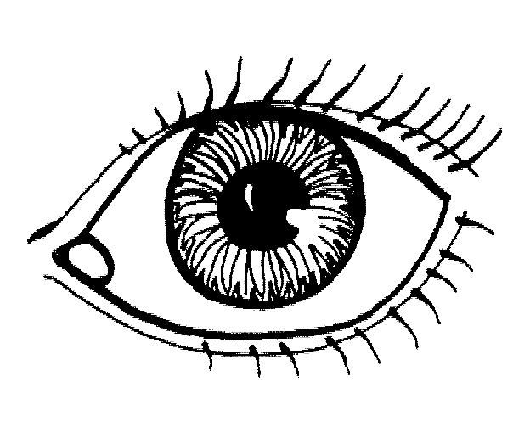

|  |  |  |  |  |  |  |  |  |  |  |  |  |
| --- | --- | --- | --- | --- | --- | --- | --- | --- | --- | --- | --- | --- |
| Oogheelkundig centrum: |  | | | | | | | | | | | |
|  | | | | | | | | | | | | |
| Honorariumnota nr.: |  | Datum: |  |  | / |  |  | / | 2 |  |  |  |

|  |  |  |  |  |  |  |  |  |  |  |  |  |  |  |  |  |  |  |  |  |  |  |  |  |  |  |  |  |  |  |  |  |  |  |  |  |  |  |  |  |  |  |  |  |  |  |  |  |  |  |  |  |  |  |  |
| --- | --- | --- | --- | --- | --- | --- | --- | --- | --- | --- | --- | --- | --- | --- | --- | --- | --- | --- | --- | --- | --- | --- | --- | --- | --- | --- | --- | --- | --- | --- | --- | --- | --- | --- | --- | --- | --- | --- | --- | --- | --- | --- | --- | --- | --- | --- | --- | --- | --- | --- | --- | --- | --- | --- | --- |
| **Patiënt** | | | | | | | | | | | | | | | | | | | | | | | | | | | | | | | | | | | | | | | | | | | | | | | | | | | | | | | |
|  | | | | | | | | | | | | | | | | | | | | | | | | | | | | | | | | | | | | | | | | | | | | | | | | | | | | | | | |
| Medi-Card® nr. en/of polisnr. | | | | | | | | |  | |  | |  | |  | |  | |  | |  | |  | |  | |  | |  |  |  |  | |  | |  | |  | |  | |  | |  | |  | |  | |  | |  | |  | |
|  | | | | | |  | | | | | | | | | | | | | | | | | | | | | | | | | | | | | | | | | | | | | | | | | | | | | | | | | |
| Naam |  |  |  |  |  | |  |  | |  | |  | |  | |  | |  | |  | |  | |  | |  | | Voornaam | | | | |  | |  | |  | |  | |  | |  | |  | |  | |  | |  | |  | |  |

|  |  |  |  |  |  |  |  |  |  |  |
| --- | --- | --- | --- | --- | --- | --- | --- | --- | --- | --- |
| Geboortedatum |  |  | / |  |  | / |  |  |  |  |

|  |  |  |  |  |  |  |  |  |  |  |  |  |  |  |  |  |  |  |  |  |  |  |  |  |  |  |  |  |  |  |  |  |
| --- | --- | --- | --- | --- | --- | --- | --- | --- | --- | --- | --- | --- | --- | --- | --- | --- | --- | --- | --- | --- | --- | --- | --- | --- | --- | --- | --- | --- | --- | --- | --- | --- |
| Straat |  |  |  |  |  |  |  |  |  |  |  |  |  |  |  |  |  |  |  |  |  |  |  |  |  |  |  |  |  |  |  |  |

|  |  |  |  |  |  |  |  |  |  |  |  |  |  |  |  |  |  |  |  |  |  |  |  |  |  |
| --- | --- | --- | --- | --- | --- | --- | --- | --- | --- | --- | --- | --- | --- | --- | --- | --- | --- | --- | --- | --- | --- | --- | --- | --- | --- |
| Nr. |  |  |  |  | Bus |  |  |  | Postcode |  |  |  |  | Gemeente |  |  |  |  |  |  |  |  |  |  |  |

|  |  |  |
| --- | --- | --- |
| **Type ingreep:** |  | 🞏 **linkeroog** 🞏 **rechteroog** |

|  |  |  |  |  |  |  |  |  |  |  |
| --- | --- | --- | --- | --- | --- | --- | --- | --- | --- | --- |
| **Datum ingreep:** |  |  | / |  |  | / | 2 |  |  |  |

**Honoraria - Medisch materiaal - Implantaten**

|  |  |  |
| --- | --- | --- |
| Omschrijving verstrekkingen  (incl. notificatienrs.(1)) | Nomenclatuurcodes(1) | Honoraria (2) |
|  |  |  |
|  |  |  |
|  |  |  |
|  |  |  |
|  |  |  |
|  |  |  |
|  |  |  |
|  |  |  |
|  |  |  |
|  |  |  |
|  |  |  |
|  |  |  |
|  |  |  |
|  |  |  |
|  |  |  |

|  |  |  |
| --- | --- | --- |
|  | **Algemeen Totaal** | € |

|  |  |  |
| --- | --- | --- |
| Het forfaitair aandeel van | **€** | (per oog), ten laste van DKV, is te betalen: |

|  |  |  |  |  |  |  |  |  |  |  |  |  |  |  |  |  |  |  |  |
| --- | --- | --- | --- | --- | --- | --- | --- | --- | --- | --- | --- | --- | --- | --- | --- | --- | --- | --- | --- |
| op IBAN rekeningnr.: | B | E |  |  | - |  |  |  |  | - |  |  |  |  | - |  |  |  |  |

|  |  |  |  |  |  |  |  |  |  |  |  |  |  |  |  |  |  |  |  |  |  |  |  |  |  |  |  |  |  |
| --- | --- | --- | --- | --- | --- | --- | --- | --- | --- | --- | --- | --- | --- | --- | --- | --- | --- | --- | --- | --- | --- | --- | --- | --- | --- | --- | --- | --- | --- |
| op naam van: |  |  |  |  |  |  |  |  |  |  |  |  |  |  |  |  |  |  |  |  |  |  |  |  |  |  |  |  |  |

|  |  |
| --- | --- |
| mededeling: |  |

66614_NL_4_201401

De zorgverstrekker (RIZV-identificatienr., naam en handtekening):

(1) Indien van toepassing

(2) Prijs vóór aftrek van tussenkomsten ziekenfonds en DKV : zie respectievelijk het getuigschrift voor verstrekte hulp (door de rechthebbende te overhandigen aan het ziekenfonds) + ‘all-in’ forfait per oog (te betalen door DKV).

|  |  |  |
| --- | --- | --- |
| **EXTRA-MURALE OOGHEELKUNDE** | | |
| **HEELKUNDIGE BEHANDELINGEN** | **RIZIV-NOMENCLATUUR** | **FORFAITAIRE TUSSENKOMST DKV  (‘ALL-IN’ FORFAIT PER OOG)** |
|  |  |  |
| Cataractoperatie | 246912 - 246923 | 831 € |
| Cataract - secundaire implant | 246610 - 246621 | 512 € |
| Enten van een hoornvlies | 246212 - 246223 | 731 € |
| Enten hoornvlies met cataractoperatie | 246890 - 246901 | 1.189 € |
| Vitrectomie | 246654 - 246665 | 1.097 €  66614_NL_4_201401 |
| Herstel ablatio retinae | 246772 - 246783 | 1.097 € |
| Intravitreale injectie | 248334 - 248345 | 123 € |
| Strabisme primaire | 247590 - 247601 | 585 € |
| Strabisme heringreep | 247656 - 247660 | 1.097 € |
| Enucleatie | 247052 - 247063 | 438 € |
| Trabeculectomie (glaucoom) | 246573 - 246584 | 548 € |
| Iridectomie | 246551 - 246562 | 438 € |

|  |  |  |
| --- | --- | --- |
| Entropium of ectropium* | 245851 - 245862 | 293 € |
| Blepharoplastie medisch* | 245733 - 245744 | 293 € |
| Ptosis* | 245814 - 245825 | 476 € |
| Pterygium* | 246094 - 246105 | 152 € |

**\*voorafgaandelijk schriftelijk akkoord van DKV vereist**

In toepassing van de overeenkomsten tussen de Werkgroep Extramurale Oogheelkunde (vereniging ondersteund door het Oogheelkundig Syndicaat ‘SOOS’, de Belgische Beroepsvereniging van Oogheelkundigen ‘BBO’ en de Belgian Society of Cataract and Refractive Surgery ‘BSCRS’) en DKV Belgium N.V., afgesloten in januari 2010 en in december 2012.